Walkthrough 23 Custom Formatters

<https://sapui5.hana.ondemand.com/#/topic/0f8626ed7b7542ffaa44601828db20de>

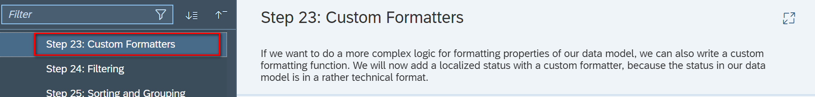

Core Changed Codes Compared to Last Version:

formatter.js:通过发票状态Key返回可读性状态文本

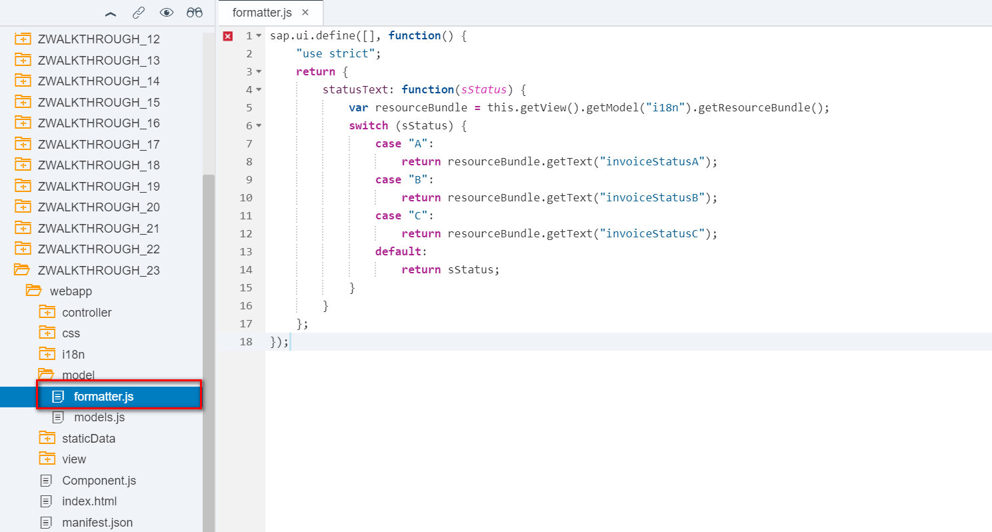

InvoiceList.controller.js:初始化formatter对象以允许后续在视图中访问

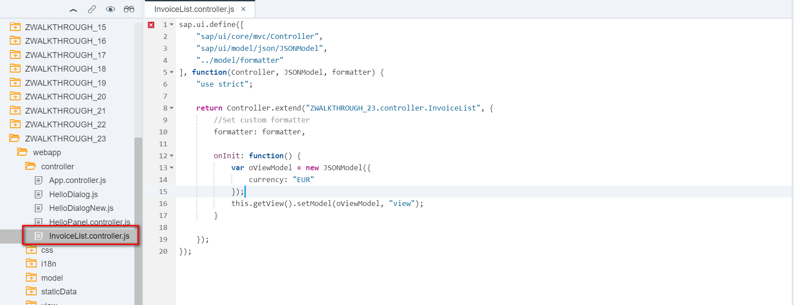

InvoiceList.view.xml:添加状态属性

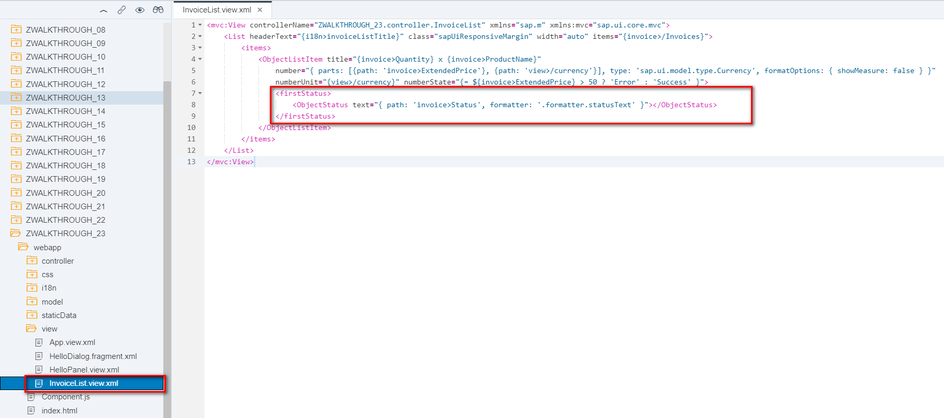

关于客制化格式的其他详细用法,请参考以下链接

<https://sapui5.hana.ondemand.com/#/topic/07e4b920f5734fd78fdaa236f26236d8.html>

i18n 文本对象管理

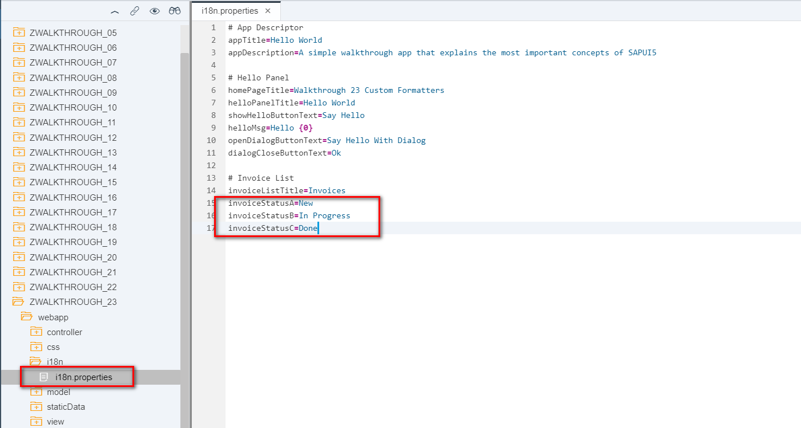

Result

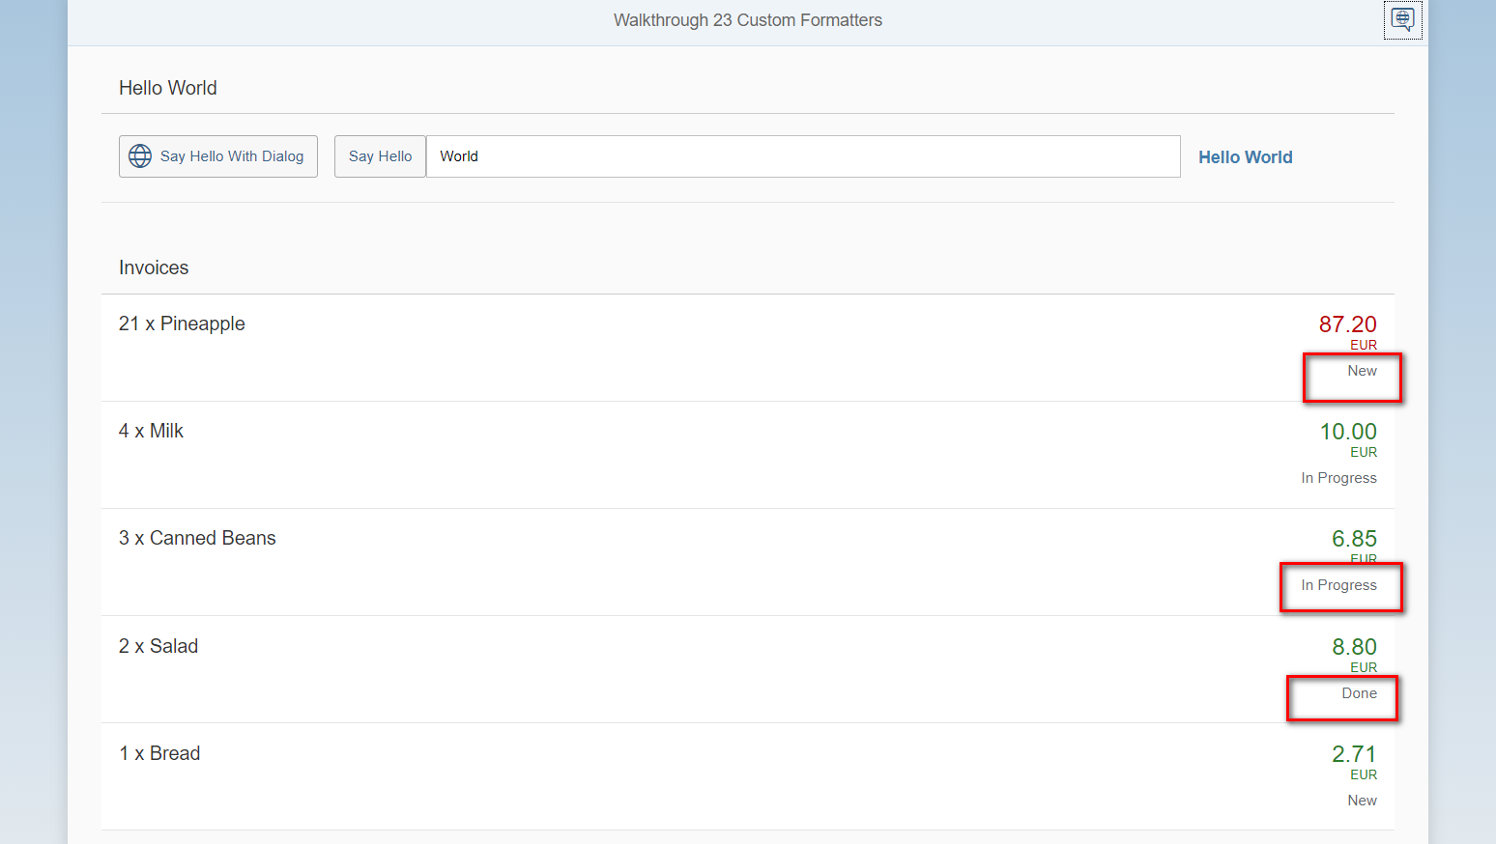

Git:

https://github.com/xiexiaop/SAPUI5-2-Round/tree/master/Projects/ZWALKTHROUGH_23

2019/02/04 XiaoMi Beijing Zac,Xie